INTERNET PROGRAMMING LAB
Online Bus Ticket Booking

Aim
To design and develop an Online Bus Ticket Booking system where users search buses by route and date, book and cancel tickets and post comments, and the administrator manages categories, buses, bookings and reports.

Technologies Used
- HTML5 - page structure and forms
- CSS3 - responsive layout and styling
- JavaScript (ES6) - client-side logic, validation and role-based access
- Browser localStorage - data storage (no server needed)

Modules and Functionalities
Admin
- Bus Categories
- Add / Update Bus
- Bookings
- User Comments
- Registered Users
- Reports
- My Profile
User
- Search & Book
- My Bookings
- Post Comment
- My Profile

Business Rules Implemented
- A seat number is allotted at booking and available seats are reduced.
- Cancelling a ticket returns the seat to the bus.
- Admin report shows total revenue and record counts.

Algorithm / Procedure
- Open the HTML file in a web browser; the login page is displayed.
- Log in with an existing account, or register a new user (Register button).
- On login, the menu for that role is built from the role-page configuration.
- Each page reads and writes records through the common save() routine, which runs the validation rules and updates stock/amount.
- Tables are rendered from the stored records; search and filter options refine the list.
- Logout clears the session and returns to the login page.

Demo Login Details
Role | Username | Password
Admin | admin | admin123
User | user | user123

Source Code
File: 03_bus_ticket_booking.html
<!DOCTYPE html>
<html lang="en">
<head>
<meta charset="utf-8" />
<meta name="viewport" content="width=device-width,initial-scale=1" />
<title>Online Bus Ticket Booking</title>
<style>
:root {
--c: #c0392b;
}
* {
box-sizing: border-box;
}
body {
margin: 0;
font-family: system-ui, Arial, sans-serif;
background: #f4f6fa;
color: #222;
}
header {
background: var(--c);
color: #fff;
padding: 12px 20px;
display: flex;
flex-wrap: wrap;
gap: 10px;
align-items: center;
justify-content: space-between;
}
header h1 {
font-size: 1.2rem;
margin: 0;
}
nav {
display: flex;
flex-wrap: wrap;
gap: 6px;
align-items: center;
}
nav button {
background: #fff;
color: var(--c);
border: 0;
border-radius: 6px;
padding: 7px 12px;
cursor: pointer;
font-size: 0.88rem;
}
.b {
background: var(--c);
color: #fff;
border: 0;
border-radius: 6px;
padding: 7px 12px;
cursor: pointer;
margin: 2px;
font-size: 0.88rem;
}
.b.r {
background: #c0392b;
}
main {
max-width: 1150px;
margin: 20px auto;
padding: 0 14px;
}
.card {
background: #fff;
border-radius: 10px;
padding: 16px;
margin: 12px 0;
box-shadow: 0 1px 4px #0002;
}
label {
display: block;
font-size: 0.85rem;
margin: 8px 0 3px;
}
input,
select {
width: 100%;
padding: 8px;
border: 1px solid #bbb;
border-radius: 6px;
font: inherit;
}
.g {
display: grid;
grid-template-columns: repeat(auto-fit, minmax(210px, 1fr));
gap: 0 14px;
}
table {
width: 100%;
border-collapse: collapse;
background: #fff;
}
th,
td {
padding: 8px;
border-bottom: 1px solid #e3e3e3;
text-align: left;
font-size: 0.86rem;
}
th {
background: #eef1f6;
}
.tw {
overflow-x: auto;
}
.s {
display: flex;
gap: 8px;
flex-wrap: wrap;
align-items: center;
}
.s input,
.s select {
width: auto;
flex: 1;
min-width: 140px;
}
.stat {
display: inline-block;
background: #fff;
border-left: 5px solid var(--c);
padding: 12px 20px;
margin: 6px;
border-radius: 8px;
box-shadow: 0 1px 4px #0002;
}
.stat b {
font-size: 1.5rem;
display: block;
}
a {
color: var(--c);
}
small {
color: #666;
}
</style>
</head>
<body>
<header>
<h1>🚌 Online Bus Ticket Booking</h1>
<nav id="nav"></nav>
</header>
<main id="main"></main>
<footer style="text-align: center; padding: 20px">
<small
>Demo app - data is stored in your browser (localStorage) -
<a
href="#"
onclick="
resetDemo();
return false;
"
>reset demo data</a
></small
>
</footer>
<script>
const A = {
id: "exp3",
t: "Online Bus Ticket Booking",
roles: { Admin: { reg: 0 }, User: { reg: 1 } },
ent: {
Categories: "name",
Buses:
"name,category:ref:Categories.name,route,date:date,time,seats:number,fare:number,description?",
Bookings:
"bus,passenger,seatNo~:number,payment:select:Card|UPI|NetBanking,amount~:number,status~:select:Booked|Cancelled",
Comments: "bus:ref:Buses.name,comment",
},
seed: {
Categories: "Volvo;Sleeper Coach;AC Coach",
Buses:
"Express 101|Volvo|Chennai-Bangalore|2026-11-05|22:00|40|850|AC Volvo multi-axle;Night Rider|Sleeper Coach|Chennai-Madurai|2026-11-06|21:30|30|700|Sleeper berths;City Link|AC Coach|Chennai-Coimbatore|2026-11-07|23:00|35|650|Push-back seats",
},
pages: {
Admin: [
["Bus Categories", "crud", "Categories"],
["Add / Update Bus", "crud", "Buses"],
["Bookings", "crud", "Bookings"],
["User Comments", "crud", "Comments"],
["Registered Users", "users", "User"],
["Reports", "report", "", { sum: [["Revenue (Rs)", "Bookings", "amount"]] }],
],
User: [
[
"Search & Book",
"browse",
"Buses",
{
find: "route,name,date",
flt: "category",
acts: [["Book Ticket", "Bookings", { bus: "name" }]],
},
],
[
"My Bookings",
"mine",
"Bookings",
{ sets: [["Cancel Ticket", { status: "Cancelled" }, "status", "Cancelled"]], print: 1 },
],
["Post Comment", "add", "Comments", {}],
],
},
inv: {
Bookings: {
to: "Buses",
key: "name",
f: "bus",
stock: "seats",
price: "fare",
rel: ["status", "Cancelled"],
},
},
own: {},
};
const P = A.id + "_",
$ = (i) => document.getElementById(i);
const mem = {},
LS = (() => {
try {
localStorage.setItem("_t", 1);
localStorage.removeItem("_t");
const l = localStorage;
return {
getItem: (k) => l.getItem(k),
setItem: (k, v) => l.setItem(k, v),
removeItem: (k) => l.removeItem(k),
keys: () => Object.keys(l),
};
} catch (e) {
return {
getItem: (k) => mem[k] ?? null,
setItem: (k, v) => {
mem[k] = String(v);
},
removeItem: (k) => {
delete mem[k];
},
keys: () => Object.keys(mem),
};
}
})();
const SS = {
get: (k) => {
try {
return sessionStorage.getItem(k) || mem["s" + k];
} catch (e) {
return mem["s" + k];
}
},
set: (k, v) => {
mem["s" + k] = v;
try {
sessionStorage.setItem(k, v);
} catch (e) {}
},
del: (k) => {
delete mem["s" + k];
try {
sessionStorage.removeItem(k);
} catch (e) {}
},
};
const L = (s) => JSON.parse(LS.getItem(P + s) || "[]"),
W = (s, v) => LS.setItem(P + s, JSON.stringify(v));
const today = () => new Date().toISOString().slice(0, 10),
add = (d, n) => {
const x = new Date(d);
x.setDate(x.getDate() + n);
return x.toISOString().slice(0, 10);
},
diff = (a, b) => Math.round((new Date(b) - new Date(a)) / 864e5);
const uid = () => Date.now().toString(36) + Math.random().toString(36).slice(2, 6);
const lab = (k) => k.replace(/([A-Z])/g, " $1").replace(/^./, (c) => c.toUpperCase());
const E = (s) =>
String(s ?? "").replace(
/[&<>"]/g,
(c) => ({ "&": "&amp;", "<": "&lt;", ">": "&gt;", '"': "&quot;" })[c],
);
const FS = (s) =>
s.split(",").map((x) => {
let [k, t = "text", ...o] = x.split(":");
const auto = k.endsWith("~"),
opt = auto || k.endsWith("?");
k = k.replace(/[~?]$/, "");
return { k, t, auto, opt, o: o.join(":").split("|") };
});
let act = [];
const R = (f) => act.push(f) - 1;
const me = () => L("Users").find((u) => u.id == SS.get(P + "me"));
const roles = Object.keys(A.roles),
adm = roles[0],
slug = (r) => r.toLowerCase().replace(/\W/g, "");
const M = (h) => {
$("main").innerHTML = h;
};
const HK = {},
CALC = {};
let BD = () => "";

Object.assign(HK, {
Bookings: (v, old) => {
if (!old) {
const b = L("Buses").find((x) => x.name == v.bus);
if (b) v.seatNo = b.seats;
}
},
});
Object.assign(CALC, {});
BD = () => "";
const inp = (f, v, ro) => {
const id = "f_" + f.k,
d = ro ? "disabled" : "";
if (f.t == "select" || f.t == "ref") {
let os = f.o;
if (f.t == "ref") {
const [e, k] = f.o[0].split(".");
os = [...new Set(L(e).map((r) => r[k]))];
}
return `<select id=${id} ${d}>${os.map((o) => `<option ${o == v ? "selected" : ""}>${E(o)}</option>`).join("")}</select>`;
}
return `<input id=${id} type=${["number", "date", "password"].includes(f.t) ? f.t : "text"} value="${E(v)}" ${d}>`;
};
const form = (fs, v = {}, ro = [], hide) =>
`<div class=g>${fs
.filter((f) => !(hide && f.auto))
.map(
(f) =>
`<div><label>${lab(f.k)}${f.opt ? "" : " *"}</label>${inp(f, v[f.k] ?? "", ro.includes(f.k))}</div>`,
)
.join("")}</div>`;
function read(fs, hide, old) {
const o = {};
for (const f of fs) {
if (hide && f.auto) {
if (!old) o[f.k] = f.t == "select" ? f.o[0] : f.t == "number" ? 0 : "";
continue;
}
const v = $("f_" + f.k).value.trim();
if (v === "" && !f.opt) {
alert("Please fill: " + lab(f.k));
return null;
}
o[f.k] = f.t == "number" && v !== "" ? +v : v;
}
return o;
}
function cell(f, v) {
if (f.t == "map")
return v
? `<a target=_blank href="https://www.google.com/maps/search/?api=1&query=${encodeURIComponent(v)}">&#128205; Map</a>`
: "";
return /^https?:/.test(v) ? `<a target=_blank href="${E(v)}">Open / Download</a>` : E(v);
}
function T(fs, rows, acts = [], xc) {
const ex = xc ? rows.map(xc) : [],
xk = ex[0] ? Object.keys(ex[0]) : [];
return `<div class=tw><table><tr>${fs.map((f) => `<th>${lab(f.k)}</th>`).join("")}${xk.map((k) => `<th>${lab(k)}</th>`).join("")}<th></th></tr>${rows.map((r, i) => `<tr>${fs.map((f) => `<td>${cell(f, r[f.k])}</td>`).join("")}${xk.map((k) => `<td>${E(ex[i][k])}</td>`).join("")}<td>${acts.map((a) => `<button class="b ${a[2] || ""}" onclick="act[${R(() => a[1](r))}]()">${a[0]}</button>`).join("")}</td></tr>`).join("") || "<tr><td colspan=30>No records found</td></tr>"}</table></div>`;
}
function inv(iv, v, old) {
const items = L(iv.to),
it = items.find((x) => x[iv.key] == (v[iv.f] ?? (old && old[iv.f])));
if (!it) return "Item not found";
const q = iv.qty ? +(v[iv.qty] ?? (old && old[iv.qty]) ?? 1) : 1,
[rk, rv] = iv.rel;
if (!old) {
if (it[iv.stock] < q) {
if (iv.wl) v.status = "Waiting";
else return "Sorry, not available / out of stock";
} else it[iv.stock] -= q;
if (iv.price) v.amount = it[iv.price] * q;
} else if (old[rk] != rv && v[rk] == rv && old.status != "Waiting") it[iv.stock] += q;
W(iv.to, items);
}
function save(en, v, old) {
const m = me();
v.owner = old ? old.owner : m.id;
if (!old) {
v.by = m.id;
const o = A.own && A.own[en];
if (o) {
const u = L("Users").find((u) => u.username == v[o]);
if (u) v.owner = u.id;
}
}
const h = HK[en];
if (h) {
const e = h(v, old);
if (e) {
alert(e);
return;
}
}
const iv = A.inv && A.inv[en];
if (iv) {
const e = inv(iv, v, old);
if (e) {
alert(e);
return;
}
}
const rows = L(en);
if (old) {
const i = rows.findIndex((r) => r.id == old.id);
rows[i] = { ...old, ...v };
} else {
v.id = uid();
v.created = today();
rows.push(v);
}
W(en, rows);
return 1;
}
function crud(l, en, o, ed) {
act = [];
const fs = FS(A.ent[en]);
M(
`<h2>${l}</h2><div class=card><h3>${ed ? "Edit record" : "Add new"}</h3>${form(fs, ed || {})}<br><button class=b onclick="act[${R(
() => {
const v = read(fs);
if (v && save(en, v, ed)) crud(l, en, o);
},
)}]()">Save</button>${ed ? `<button class=b onclick="act[${R(() => crud(l, en, o))}]()">Cancel</button>` : ""}</div>${T(
fs,
L(en),
[
["Edit", (r) => crud(l, en, o, r)],
[
"Delete",
(r) => {
if (confirm("Delete this record?")) {
W(
en,
L(en).filter((x) => x.id != r.id),
);
crud(l, en, o);
}
},
"r",
],
],
CALC[en],
)}`,
);
}
function doAct(a, item, back, src) {
const [lb, to, map, direct] = a,
fs = FS(A.ent[to]),
pre = {};
for (const k in map) {
const s = map[k];
pre[k] = s[0] == "=" ? s.slice(1) : item[s];
}
const fin = (v) => {
if (v && save(to, v)) {
if (src)
W(
src[0],
L(src[0]).filter((x) => x.id != src[1]),
);
alert("Done: " + lb);
back();
}
};
if (direct) {
const v = {};
fs.forEach(
(f) =>
(v[f.k] =
f.k in pre
? f.t == "number"
? +pre[f.k]
: pre[f.k]
: f.t == "select"
? f.o[0]
: f.t == "number"
? 0
: ""),
);
return fin(v);
}
act = [];
M(
`<h2>${lb}</h2><div class=card>${form(fs, pre, Object.keys(pre), 1)}<br><button class=b onclick="act[${R(() => fin(read(fs, 1)))}]()">Confirm</button><button class=b onclick="act[${R(back)}]()">Back</button></div>`,
);
}
function browse(l, en, o, q0 = "") {
act = [];
const fs = FS(A.ent[en]),
find = (o.find || fs[0].k).split(","),
fl = o.flt,
back = () => browse(l, en, o);
const draw = () => {
const q = $("q").value.toLowerCase(),
f = fl ? $("fl").value : "",
mx = o.rng && $("mx").value;
const rs = L(en).filter(
(r) =>
find.some((k) => String(r[k]).toLowerCase().includes(q)) &&
(!f || r[fl] == f) &&
(!mx || r[o.rng] <= +mx),
);
$("res").innerHTML = T(
fs,
rs,
(o.acts || []).map((a) => [a[0], (r) => doAct(a, r, back)]),
CALC[en],
);
};
const di = R(draw);
M(
`<h2>${l}</h2><div class="card s"><input id=q oninput="act[${di}]()" placeholder="Search by ${find.map(lab).join(", ")}" value="${E(q0)}">${fl ? `<select id=fl onchange="act[${di}]()"><option value="">All ${lab(fl)}</option>${[...new Set(L(en).map((r) => r[fl]))].map((v) => `<option>${E(v)}</option>`).join("")}</select>` : ""}${o.rng ? `<input id=mx type=number oninput="act[${di}]()" placeholder="Max ${lab(o.rng)}">` : ""}<button class=b onclick="act[${di}]()">Search</button></div><div id=res></div>`,
);
draw();
}
function mine(l, en, o) {
act = [];
const fs = FS(A.ent[en]),
m = me(),
back = () => mine(l, en, o);
let rows = L(en).filter((r) => r.owner == m.id);
if (o.cf) rows = rows.filter((r) => CALC[en](r)[o.cf] > 0);
const ac = [];
(o.sets || []).forEach((s) =>
ac.push([
s[0],
(r) => {
if (r[s[2]] == s[3]) return alert("Not applicable");
if (save(en, { ...s[1] }, r)) back();
},
"r",
]),
);
if (o.edit)
ac.push([
"Modify",
(r) => {
act = [];
M(
`<h2>Modify</h2><div class=card>${form(fs, r, [], 1)}<br><button class=b onclick="act[${R(
() => {
const v = read(fs, 1, r);
if (v && save(en, v, r)) back();
},
)}]()">Save</button><button class=b onclick="act[${R(back)}]()">Back</button></div>`,
);
},
]);
if (o.mv) ac.push([o.mv[0], (r) => doAct(o.mv, r, back, [en, r.id])]);
if (o.run)
ac.push([
o.run[0],
(r) => {
const p = A.pages[m.role].find((x) => x[0] == o.run[1]);
browse(p[0], p[2], p[3] || {}, r[o.run[2]]);
},
]);
if (o.print)
ac.push([
"Print",
(r) => {
const w = window.open("", "_blank");
w.document.write(
"<h2>" +
E(A.t) +
" - Ticket</h2>" +
Object.entries(r)
.filter(([k]) => !["id", "owner", "by"].includes(k))
.map(([k, v]) => "<p><b>" + lab(k) + ":</b> " + E(v) + "</p>")
.join(""),
);
w.document.close();
w.print();
},
]);
if (o.qr)
ac.push([
o.qr[0],
(r) => {
const c = r[o.qr[1]];
if (!c) return alert("Not available yet - waiting for approval");
const d = $("qr");
d.style.display = "block";
d.innerHTML = "<h3>" + E(c) + "</h3><div id=qc></div>";
window.QRCode && new QRCode($("qc"), c);
},
]);
if (o.del)
ac.push([
"Remove",
(r) => {
W(
en,
L(en).filter((x) => x.id != r.id),
);
back();
},
"r",
]);
M(`<h2>${l}</h2>${T(fs, rows, ac, CALC[en])}<div id=qr class=card style="display:none"></div>`);
}
function addp(l, en, o) {
act = [];
const fs = FS(A.ent[en]),
m = me(),
v0 = {};
for (const k in o.def || {}) v0[k] = o.def[k] == "@today" ? today() : o.def[k];
M(
`<h2>${l}</h2><div class=card>${form(fs, v0, [], 1)}<br><button class=b onclick="act[${R(() => {
const v = read(fs, 1);
if (v && save(en, v)) {
alert("Saved successfully");
addp(l, en, o);
}
})}]()">Submit</button></div><h3>Records</h3>${T(
fs,
L(en).filter((r) => m.role == adm || r.by == m.id),
[],
CALC[en],
)}`,
);
}
function profile() {
act = [];
const fs = FS("name,email,phone,password:password"),
m = me();
M(
`<h2>My Profile</h2><div class=card><p>Role: <b>${E(m.role)}</b> &nbsp; Username: <b>${E(m.username)}</b></p>${form(fs, m)}<br><button class=b onclick="act[${R(
() => {
const v = read(fs);
if (!v) return;
const u = L("Users");
Object.assign(
u.find((x) => x.id == m.id),
v,
);
W("Users", u);
alert("Profile updated");
profile();
},
)}]()">Update</button></div>`,
);
}
function report(l, _, o) {
act = [];
M(
`<h2>${l}</h2>${(o.sum || [])
.map(
(s) =>
`<div class=stat><b>${L(s[1])
.filter((r) => s[3] || r.status != "Cancelled")
.reduce((a, r) => a + (+r[s[2]] || 0), 0)}</b>${s[0]}</div>`,
)
.join("")}<br>${Object.keys(A.ent)
.map((e) => `<div class=stat><b>${L(e).length}</b>${lab(e)}</div>`)
.join(
"",
)}<br>${roles.map((r) => `<div class=stat><b>${L("Users").filter((u) => u.role == r).length}</b>${E(r)} accounts</div>`).join("")}`,
);
}
function users(l, role) {
act = [];
M(
`<h2>${l}</h2>${T(
FS("name,username,email,phone"),
L("Users").filter((u) => u.role == role),
[
[
"Delete",
(r) => {
if (confirm("Delete user?")) {
W(
"Users",
L("Users").filter((x) => x.id != r.id),
);
users(l, role);
}
},
"r",
],
],
)}`,
);
}
function approve(l, role) {
act = [];
M(
`<h2>${l}</h2>${T(
FS("name,username,email,phone,approved"),
L("Users").filter((u) => u.role == role),
[
[
"Approve",
(r) => {
const u = L("Users");
u.find((x) => x.id == r.id).approved = 1;
W("Users", u);
approve(l, role);
},
],
[
"Reject",
(r) => {
W(
"Users",
L("Users").filter((x) => x.id != r.id),
);
approve(l, role);
},
"r",
],
],
)}`,
);
}
function newuser(l, role) {
act = [];
const fs = FS("name,username,password:password,email,phone");
M(
`<h2>${l}</h2><div class=card>${form(fs)}<br><button class=b onclick="act[${R(() => {
const v = read(fs);
if (!v) return;
if (L("Users").some((u) => u.username == v.username)) return alert("Username already exists");
W("Users", [...L("Users"), { ...v, id: uid(), role, approved: 1 }]);
alert(role + " account created");
newuser(l, role);
})}]()">Create</button></div>${T(
FS("name,username,email,phone"),
L("Users").filter((u) => u.role == role),
)}`,
);
}
function find(l, en, o) {
act = [];
const fs = FS(A.ent[en]);
M(
`<h2>${l}</h2><div class="card s"><input id=k placeholder="Enter ${lab(o.key)}"><button class=b onclick="act[${R(
() => {
const k = $("k").value.trim();
$("res").innerHTML = T(
fs,
L(en).filter((r) => String(r[o.key]) == k),
[],
CALC[en],
);
},
)}]()">Check</button></div><div id=res></div>`,
);
}
function verify(l, _, o) {
act = [];
M(
`<h2>${l}</h2><div class="card s"><input id=k placeholder="Scan / enter QR code or ticket code"><button class=b onclick="act[${R(
() => {
const k = $("k").value.trim();
let h = "<div class=card>&#10060; <b>Invalid code</b></div>";
for (const [e, f] of o.list) {
const r = k && L(e).find((x) => x[f] == k);
if (r) h = "<div class=card>&#9989; <b>Valid " + lab(e) + "</b></div>" + T(FS(A.ent[e]), [r]);
}
$("res").innerHTML = h;
},
)}]()">Verify</button></div><div id=res></div>`,
);
}
const PG = { crud, browse, mine, add: addp, report, users, approve, newuser, find, verify };
function go(i) {
act = [];
const p = A.pages[me().role][i];
PG[p[1]](p[0], p[2], p[3] || {});
}
function home() {
const m = me();
if (!m) return login();
const ps = A.pages[m.role] || [];
$("nav").innerHTML =
ps.map((p, i) => `<button onclick="go(${i})">${p[0]}</button>`).join("") +
`<button onclick="profile()">My Profile</button><button onclick="logout()">Logout</button><span style="color:#fff;font-size:.8rem">${E(m.name)} (${E(m.role)}) ${BD()}</span>`;
ps.length ? go(0) : profile();
}
function logout() {
SS.del(P + "me");
$("nav").innerHTML = "";
login();
}
function login() {
act = [];
M(
`<div class=card style="max-width:460px;margin:30px auto"><h2>Login</h2><label>Username</label><input id=u><label>Password</label><input id=p type=password><br><br><button class=b onclick="doLogin()">Login</button><button class=b onclick="signup()">Register</button><button class=b onclick="forgot()">Forgot Password</button><hr><small>Demo accounts - click to log in instantly:</small><div>${roles.map((r) => `<button class=b onclick="doLogin('${slug(r)}','${slug(r)}123')">${r}</button>`).join("")}</div></div>`,
);
}
function doLogin(un, pw) {
un = un ?? $("u").value.trim();
pw = pw ?? $("p").value;
const u = L("Users").find((x) => x.username == un && x.password == pw);
if (!u) return alert("Invalid username or password");
if (!u.approved) return alert("Your account is awaiting admin approval");
SS.set(P + "me", u.id);
home();
}
function signup() {
act = [];
const fs = FS("name,username,password:password,email,phone"),
rr = roles.filter((r) => A.roles[r].reg);
M(
`<div class=card style="max-width:520px;margin:30px auto"><h2>Register</h2><label>Register as</label><select id=rr>${rr.map((r) => `<option>${r}</option>`).join("")}</select>${form(fs)}<br><button class=b onclick="act[${R(
() => {
const v = read(fs);
if (!v) return;
if (L("Users").some((u) => u.username == v.username)) return alert("Username already taken");
const role = $("rr").value,
ap = A.roles[role].appr;
W("Users", [...L("Users"), { ...v, id: uid(), role, approved: ap ? 0 : 1 }]);
alert(ap ? "Registered. Wait for admin approval." : "Registered. Please login.");
login();
},
)}]()">Register</button><button class=b onclick="login()">Back</button></div>`,
);
}
function forgot() {
const n = prompt("Enter your username");
if (!n) return;
const u = L("Users"),
x = u.find((y) => y.username == n);
if (!x) return alert("User not found");
const p = prompt("Enter new password");
if (!p) return;
x.password = p;
W("Users", u);
alert("Password reset. Please login.");
}
function resetDemo() {
LS.keys()
.filter((k) => k.startsWith(P))
.forEach((k) => LS.removeItem(k));
SS.del(P + "me");
location.reload();
}
if (!LS.getItem(P + "init")) {
W(
"Users",
roles.map((r) => {
const n = slug(r);
return {
id: uid(),
role: r,
username: n,
password: n + "123",
name: r + " Demo",
email: n + "@demo.com",
phone: "9999999999",
approved: 1,
};
}),
);
for (const e in A.seed) {
const fs = FS(A.ent[e]);
W(
e,
A.seed[e].split(";").map((r) => {
const o = { id: uid(), created: today() };
r.split("|").forEach((v, i) => (o[fs[i].k] = fs[i].t == "number" ? +v : v.trim()));
return o;
}),
);
}
LS.setItem(P + "init", 1);
}
me() ? home() : login();
</script>
</body>
</html>

Output
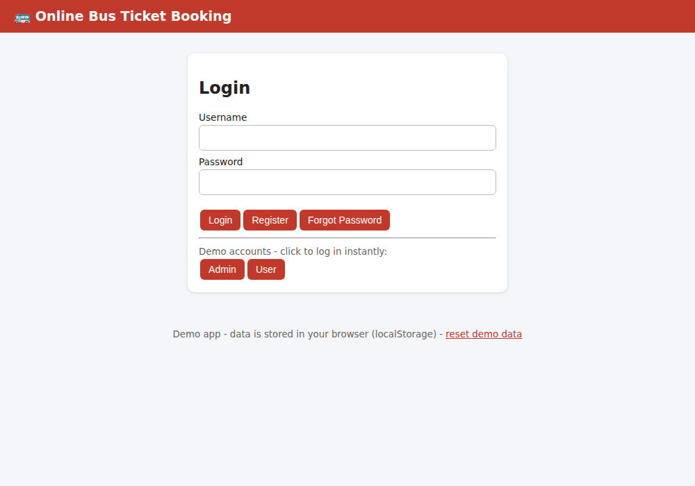
Figure 1: Login page with demo account buttons
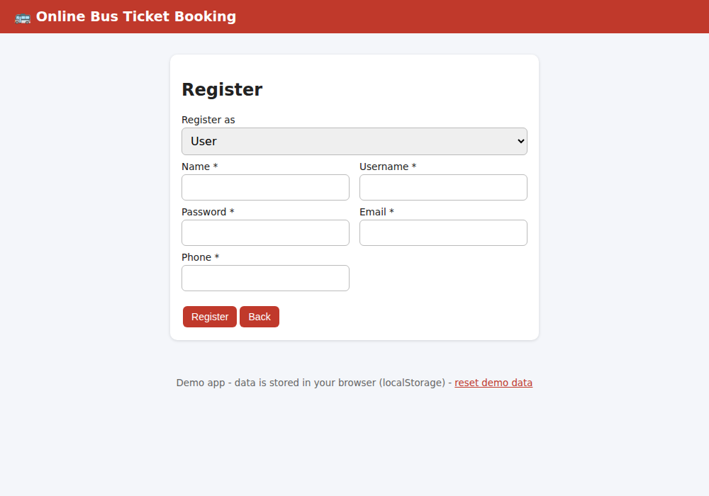
Figure 2: Registration page
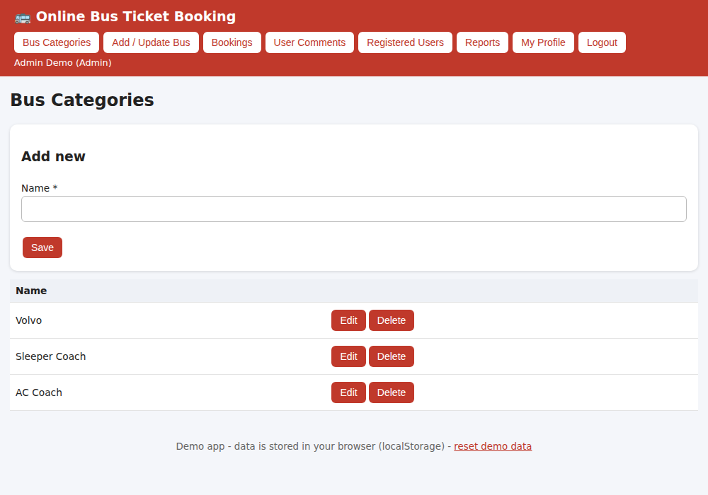
Figure 3: Admin - Bus Categories
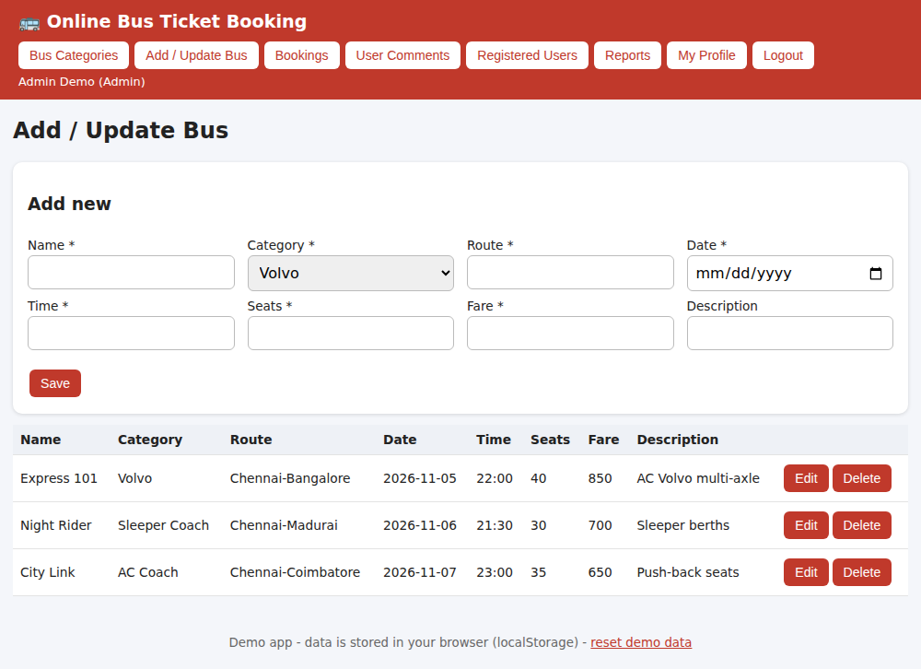
Figure 4: Admin - Add / Update Bus
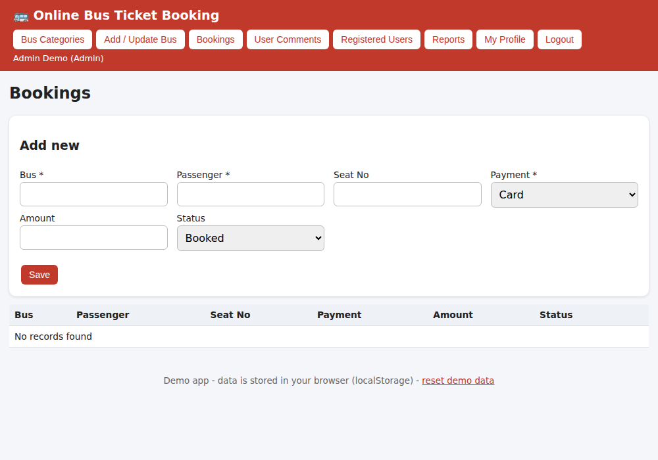
Figure 5: Admin - Bookings
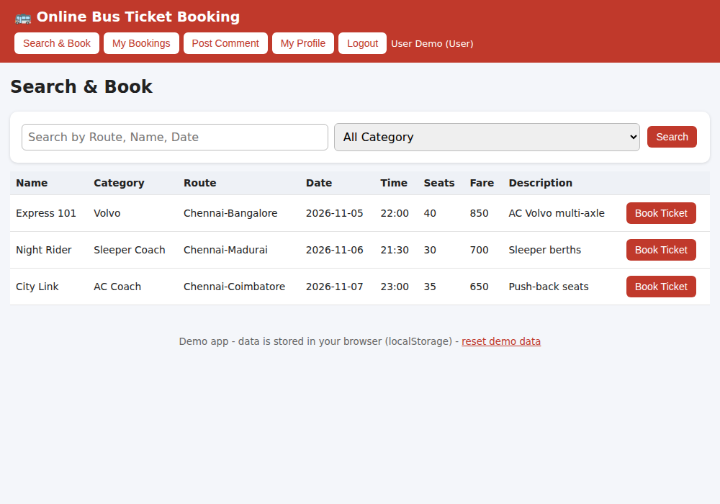
Figure 6: User - Search & Book
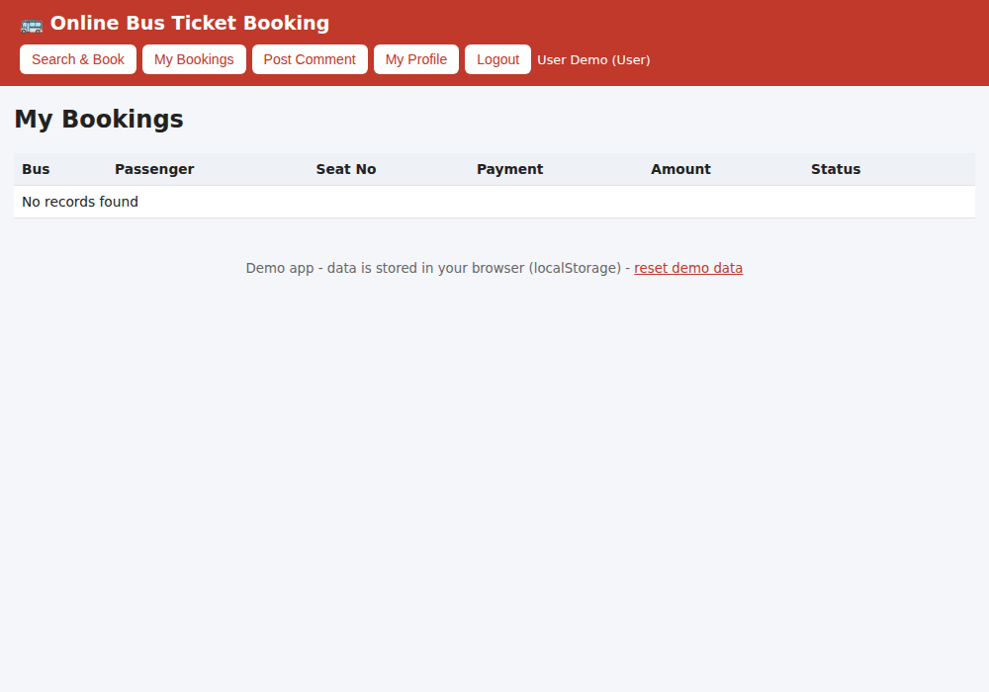
Figure 7: User - My Bookings
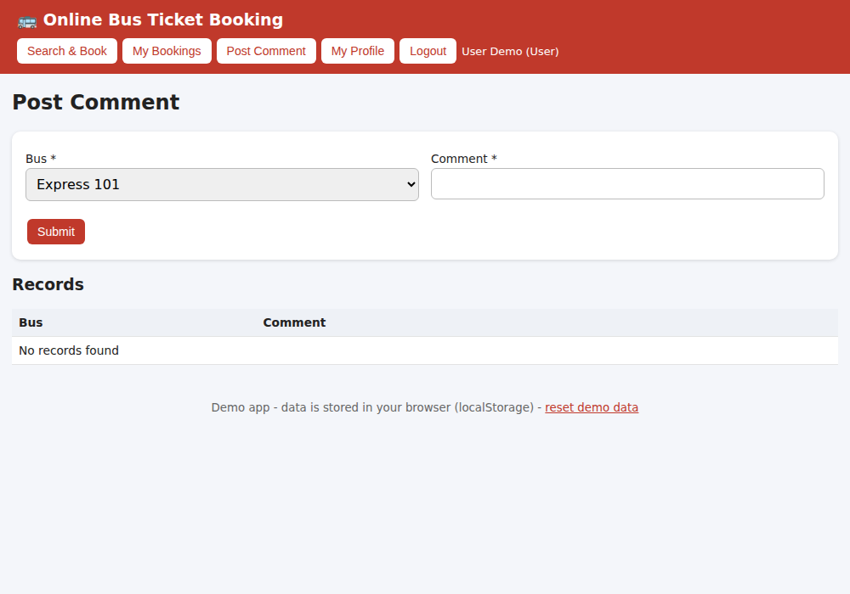
Figure 8: User - Post Comment
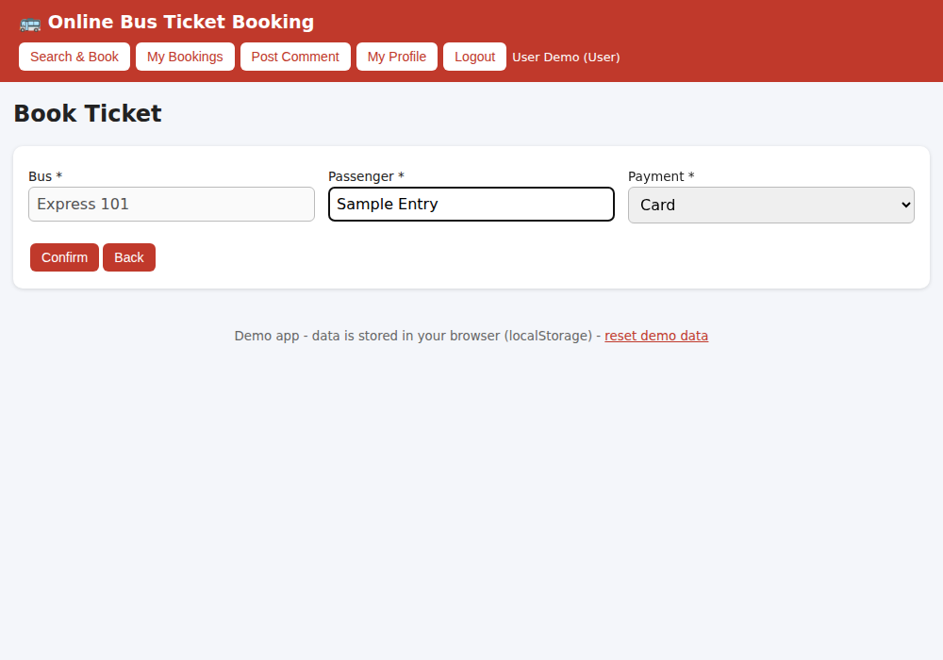
Figure 9: User - Book Ticket form (filled)
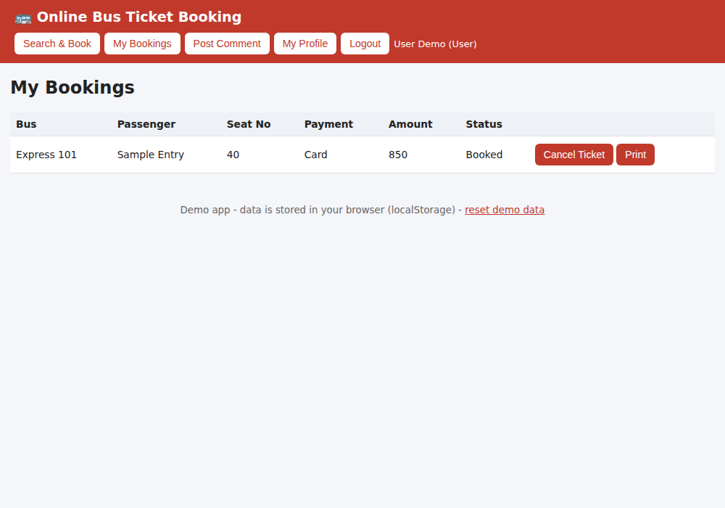
Figure 10: User - My Bookings (after Book Ticket)

Result
Thus the Online Bus Ticket Booking web application was designed, implemented and executed successfully, and the output was verified for all user roles.

